Department of Microbiology
214 Turner Road
Colchester
CO4 5JR
East Suffolk and North Essex NHS Foundation Trust
Chlamydia trachomatis & Neisseria Gonorrhoea change from current testing system to centralised Roche™ 6800 platform
Dear Colleagues, Clinicians and Healthcare Professionals
In May 2022, we sent out a communication concerning the repatriation to ESNEFT of Chlamydia / GC Molecular testing and the improvements in the service this would bring. To facilitate this change to occur we informed you about different testing collection kits which would be required to allow us to test these samples on the new in-house Roche molecular platforms used in our new Molecular Laboratory.
I am pleased to say that the change has been successful and the new testing platforms are working well. As we informed you, that during the transition period to the new testing procedures, we would continue to accept the old Hologic tubes for an interim period and these would continue to be sent to UKSHA Cambridge Laboratory for testing to allow all users to obtain the new collection kits.
I am writing to inform you that as the new testing processes are working, from the 1st September, we will no longer be able to accept samples sent in the Hologic Aptima collection tubes and these samples will be rejected from this date.
The new collection kits are available from the Pathology Consumables Website ESNEFT Pathology Service
This site also includes information on the correct taking of these samples, which can be downloaded.
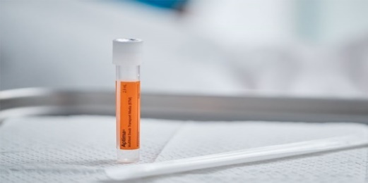 Swabs Not to be used
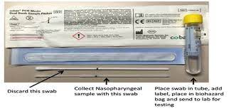 New Kits to be used
Your co-operation and assistance on this matter would be greatly appreciated.
Peter Hitchcock
Microbiology Service Lead

