Histopathology Handbook – Colchester Hospital

CONTROLLED HARDCOPIES MUST BE SIGNED.
Document owner (signature):
Document owner (Print):
Date:
Location of hardcopy

Summary of Changes:
- Changed references to Cellular Pathology to Histopathology
- Updated key members of staff, roles and deputies
- Updated document references
- Updated frozen section re high risk specimens and Covid samples
- Updated referrals list and transport
- Added information on data protection/confidentiality
- Updated TATs
- Updated department map link and complaints email address
- Minor wording changes
CONTENTS
1 SCOPE OF THIS HANDBOOK 4
2 Purpose & service background 4
3 Service information 4
3.1 MANAGEMENT OF SERVICE 4
3.2 KEY PERSONNEL CONTACT DETAILS 5
3.3 DEPARTMENT TELEPHONE NUMBERS 6
3.4 DEPARTMENT KEY ROLES AND DEPUTIES 6
3.5 LOCATION OF THE LABORATORY 7
3.6 SERVICES AND TESTS OFFERED BY THE CELLULAR PAHOLOGY LABORATORY 7
3.7 OPENING TIMES 8
3.8 CLINICAL ADVICE AND INTERPRETATION 8
3.9 NON-CLINICAL ADVICE 8
4 HISTOPATHOLOGY REQUEST FORMS & SAMPLE LABELLING 9
4.1 MANUAL HANDWRITTEN REQUEST 9
4.2 ELECTRONIC REQUEST (ORDERCOMMS) 10
5 Sample Acceptance Criteria in Histopathology 11
5.1 GENERAL INFORMATION 11
5.2 MINIMUM REQUIREMENTS FOR REQUEST FORMS AND SAMPLE LABELS 11
6 Identification of the Priority Status of Patient Samples 12
6.1 Frozen sections 12
6.2 MUSCLE BIOPSIES 13
7 Health & Safety Requirements 14
7.1 CHEMICAL HAZARDS – FORMALIN / FORMALDEHYDE 14
7.2 BIOLOGICAL HAZARDS – UNFIXED & HIGH RISK SAMPLES 14
7.3 RADIOACTIVE HAZARDS 15
8 Sample Requirements: Handling & Storage 15
8.1 HISTOLOGY SAMPLE HANDLING & STORAGE 15
8.2 GOUT CRYSTAL HISTOLOGY INVESTIGATIONS 17
8.3 IMMUNOFLUORESCENCE INVESTIGATION ON SKIN 17
8.4 FROZEN SECTION INVESTIGATION 17
8.5 DIAGNOSTIC CYTOLOGY SAMPLE HANDLING & STORAGE 17
8.6 MUSCLE BIOPSY SAMPLE HANDLING & STORAGE 20
8.7 PRODUCTS OF CONCEPTION SAMPLE HANDLING & STORAGE 21
9 Time limits for requesting additional examinations/tests 22
10 Transport of Histopathology Samples 22
10.1 TRANSPORT OF SAMPLES FROM GP SURGERIES 22
10.2 TRANSPORT OF SAMPLES FROM HOSPITAL WARDS, THEATRES AND CLINICS 22
10.3 CHAIN OF CUSTODY AND SAMPLE TRANSPORT RECORDS 23
11 Factors affecting laboratory tests 23
11.1 HISTOPATHOLOGY 23
11.2 DIAGNOSTIC CYTOLOGY 24
12 Turnaround Times 24
13 Summary of Tests Referred to Other Laboratories 24
14 Data protection and patient confidentiality 26
15 Escalation in Case of Service Failure 26
16 Feedback / Complaints / Incidents 26
17 Monitoring Compliance and Effectiveness 27

SCOPE OF THIS HANDBOOK
This User Guide has been produced to assist both hospital and community users of the Histopathology laboratory service at Colchester Hospital. It deals with access to the Histopathology service, specimen requirements, information and labelling requirements. If this User Guide fails to provide information required, users are encouraged to contact relevant key personnel listed.

Purpose & service background
Histopathology is the branch of pathology that involves the study of body organs and tissues (groups of cells). Histopathology is one of the diagnostic branches of medicine, along with radiology and other pathology specialties (e.g. microbiology, haematology, blood transfusion and biochemistry). Its roles include determining the cause of certain diseases and the effect(s) that they are having on the body, assisting with the choice of treatment that will be given, aiding in giving a prognosis and determining what may have caused a person’s death.
Histopathology is vital in those parts of medicine where a specimen of tissue or a sample of tissue cells are taken from the patient and sent to the laboratory. In these situations Histopathology is the specialty that gives the definitive diagnosis and allows clinicians to give the most appropriate advice and treatment to their patients.
There are two main subdivisions within Histopathology. The first is histology, which involves the examination of sampled whole tissues under the microscope. This is often aided by the use of special staining techniques and other associated tests. The second subdivision is cytopathology (cytology), which is the examination of single cells.
The Histology and Non Gynaecological Cytology aspects of the Histopathology service are based in Villa 6 and forms part of the ESNEFT Pathology service.
Cervical Cytology screening is not contracted to ESNEFT. This service is directly contracted to Norfolk & Norwich Hospital. Any complaints, concerns or feedback must be communicated directly with the cytology service.

Service information

MANAGEMENT OF SERVICE
The Histopathology service is managed as part of the ESNEFT Pathology service. Integration of this service into patient care at Colchester Hospital is overseen by Group 1 – Cancer and Diagnostics Division (CDG) of ESNEFT. Pathology sits in Group 1 – CDG with Cancer, Medical Imaging and Pharmacy.

KEY PERSONNEL CONTACT DETAILS
Medical Staff | Email and Telephone
Dr Yinka Fashedemi  Histopathology Clinical Speciality Lead Pathologist | Yinka.Fashedemi@esneft.nhs.uk  Contact via secretary 01206 748340  Internal: 8352
Dr Madhuri Shinkar  Lead Consultant Pathologist | Madhuri.Shinkar@esneft.nhs.uk  Contact via secretary 01206 748340  Internal: 8356
Dr Nikta Niktash  Consultant Pathologist | Nikta.Niktash@esneft.nhs.uk  Contact via secretary 01206 748340  Internal: 8357
Dr Manu Noatay  Consultant Pathologist | Manu.Noatay@esneft.nhs.uk  Contact via secretary 01206 748340  Internal: 8361
Dr Bamini Sivarajah  Consultant Pathologist | Bamini.Sivarajah@esneft.nhs.uk  Contact via secretary 01206 748340  Internal: 8360
Dr Umara Jan  Speciality Doctor | Caroline.Colville@esneft.nhs.uk  Contact via secretary 01206 748340  Internal: 8359
Dr Hasitha Weerasuriya  Speciality Doctor | Hasitha.Weerasuriya@esneft.nhs.uk  Contact via secretary 01206 748340  Internal: 8359
Dr Eleanor Coen  Speciality Doctor | Eleanor.Coen@esneft.nhs.uk  Contact via secretary 01206 748340  Internal: 8351

Biomedical Scientists | Email and Telephone
Ms Lynn Partridge  Service Manager – Histopathology | Lynn.Partridge@esneft.nhs.uk  07747 478651  01473 703227  Internal: 89 5227
Mr Chris Gratze  Interim Operations Manager | Chris.gratze@esneft.nhs.uk  01206 748345  Internal: 8345
Mr Andrew Wagerfield  Histopathology Laboratory IT Project Lead | Andrew.Wagerfield@esneft.nhs.uk  01206 748346  Internal: 8346
Mrs Claire Groves  Advanced Biomedical Scientist | ClaireGroves@esneft.nhs.uk  01206 748345  Internal: 8345
Mrs Emma Ogilvie  Advanced Biomedical Scientist | Emma.Colman@esneft.nhs.uk  01206 748345  Internal: 8345
Ms Jamie Patel  Advanced Biomedical Scientist | Jamie.Patel@nhs.net  01206 748345  Internal: 8345
Mrs Robyn Harding  Advanced Biomedical Scientist | Robyn.Harding@esneft.nhs.uk  01206 748345  Internal: 8345
Mrs Emma Pay  Histopathology Training lead | Emma.pay@esneft.nhs.uk

DEPARTMENT TELEPHONE NUMBERS
Department | Email and Telephone
Laboratory | cgh.histopathology@esneft.nhs.uk  01206 748343 Internal: 8343
Secretaries to Medical Staff | cgh.histopathology@esneft.nhs.uk  01206 748340 Internal: 8340
Specimen Reception | cgh.histopathology@esneft.nhs.uk  01206 748341 Internal: 8341

DEPARTMENT KEY ROLES AND DEPUTIES
Role | Appointed Person | Deputy
Clinical Speciality Lead | Dr Yinka Fashedemi | Local site Clinical lead
Local Clinical Lead | Dr Madhuri Shinkar | Dr Yinka Fashedemi
Service Lead | Lynn Partridge | Chris Gratze
Operations Lead | Chris Gratze | Lynn Partridge / Claire Groves / Jamie Patel / Emma Ogilvie/Robyn Harding
Training Manager | Clare Morrow | Emma Pay (Training Lead) / Lynn Partridge
Histopathology Training Lead (cross site) | Emma Pay | Clare Morrow / Jamie Patel
Quality Manager | Vacant | Karen Edwards
Health & Safety | Chris Gratze | Holly Milla
First Aid | Abigail Jeakins | Charlotte Green/Kotryna Soblinskaite
Breast MDT | Dr Madhuri Shinkar | Dr Yinka Fashedemi
Colposcopy MDT] | Dr Madhuri Shinkar | Dr Nikta Niktash
Dermatology MDT | Dr Manu Noatay | Dr Yinka Fashedemi
Gastroenterology MDT | Dr Bamini Sivarajah | Dr Yinka Fashedemi
GI-Upper MDT | Dr Bamini Sivarajah | Dr Yinka Fashedemi
GI-Colorectal MDT | Dr Bamini Sivarajah | Dr Yinka Fashedemi
Gynaecology MDT | Dr Yinka Fashedemi | Dr Manu Noatay
Respiratory MDT | Dr Nikta Niktash | Dr Manu Noatay
Urology MDT | Dr Nikta Niktash | Dr Manu Noatay
Bowel Cancer Screening Programme (BCSP) | Dr Yinka Fashedemi | Dr Bamini Sivarajah
Breast Cancer Screening Programme | Dr Madhuri Shinkar | Dr Yinka Fashedemi
Cervical Screening Programme | Dr Madhuri Shinkar | Dr Nikta Niktash
Clinical Audit | Dr Nikta Niktash | Dr Manu Noatay
Clinical Education/Training | Dr Yinka Fashedemi | Dr Manu Noatay

LOCATION OF THE LABORATORY
The Histopathology Department is located in Villa 6 on Colchester Hospital site, Turner Road, Colchester CO4 5JL
Villa 6 is signposted ‘Histopathology’ and is situated between the Iceni Centre building and former COVID19 drive though test station
For a location map click on a link below:
Colchester_2022_05_04 (esneft.nhs.uk)
Villa 6 is near the main staff car park, signposted ‘Histopathology’ and is situated between the Iceni Centre building and former COVID19 drive though test station.

SERVICES AND TESTS OFFERED BY THE CELLULAR PAHOLOGY LABORATORY
The Histopathology Department offers the following services:
- Histopathology - routine Histopathology services including, Haematoxylin and Eosin (H+E), Immunohistochemistry (IHC)
- Frozen Sections by pre-booking only see section 6.1 for full details.
- Diagnostic Cytology - diagnostic reporting service for most types of non- gynaecological cytology samples, including, serous fluids, respiratory samples, cyst fluids, joint fluids, urines and fine needle aspirations. Currently these sample types are processed offsite and reported onsite, with the exception of joint fluid which are processed and reported onsite.
- Muscle Biopsy (onward referral to Addenbrooke’s)
- Immunofluorescence (IMF) on skin biopsies (onward referral to St John’s Institute of Dermatology)
The following tissue samples should be sent directly to Blood Sciences for onward transport and not to Histopathology:
- Umbilical cord snip for cytogenetics testing.
- Barts referrals: Bone Marrow trephines and histology samples with ?Lymphoma diagnosis (e.g. lymph node biopsies etc.). Entry of returned reports is undertaken by Histopathology on the laboratory information system. Please use the form embedded below.

OPENING TIMES
The Histopathology laboratory is open Monday to Friday 09:00 – 17.30 except English public holidays.

CLINICAL ADVICE AND INTERPRETATION
Consultant grade medical members of staff are available on the telephone, and at MDT, to advise on:
- The choice of test and how to use the service including the type of sample that should be sent, whether or not a sample should be sent and the limitations of histology and diagnostic cytology.
- Individual cases including advice on the surgical report which contains the interpretation of the examinations.
- Ensuring the laboratory services are used effectively and efficiently e.g. if a specimen should be sent marked as urgent.
Please use the telephone numbers listed above.

NON-CLINICAL ADVICE
Senior Biomedical Scientists are available to give advice on technical matters including the transport of specimens, the correct containers and fixatives to use, and the requirements for acceptance criteria.
Please use the telephone numbers listed above.

HISTOPATHOLOGY REQUEST FORMS & SAMPLE LABELLING
There are two ways to order Histopathology examinations at Colchester Hospital:
- Manual handwritten request
- Electronic request (Medway OrderComms)

MANUAL HANDWRITTEN REQUEST
Manual request forms for Histopathology can be ordered through the ESNEFT Pathology website: https://esneftpathology.nhs.uk/store/#
Please contact the Pathology Service Desk https://esneftpathology.nhs.uk/contactus/ or 0300 303 5299 to request access to this system.
It is the responsibility of the requesting clinician and the sample taker to ensure that request forms and samples are correctly and identically labelled. It is essential that the risk of misreporting pathology results is minimised to ensure patient safety and to this end accurate identification of the patient from whom the specimen/ sample was obtained is of paramount importance.
Each request accepted by the Histopathology service is considered to be an agreement between the laboratory and the requestor. The same request form can be used for both histology & diagnostic cytology samples. An image of the correct request form for Histopathology at Colchester is shown below:
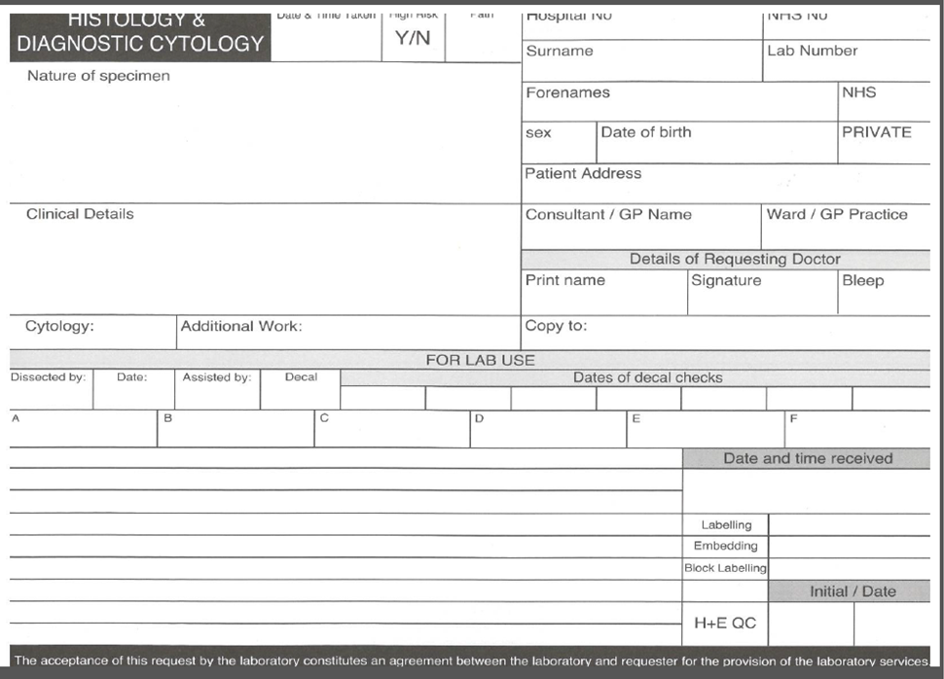

ELECTRONIC REQUEST (ORDERCOMMS)
An electronic request is made using the Careflow EPR system accessed via the Careflow EPR (LIVE) icon.
Access to Careflow EPR can be requested via the ESNEFT IT helpdesk, either va the self-service portal or on ext. 5990.
Please place a training request through the ICT training helpdesk for training ext. 6575
Once training is complete you will be given access to the Careflow EPR system.
Make the Histopathology request on Careflow EPR as per training.
Sample labels are printed from the Careflow EPR system. Attach the sample labels to all the samples related to the request. For cases with multiple samples ensure that Label “A” is attached to Sample “A” and identifies with Sample “A” on the request form. The same requirement goes for sample “B”, Sample “C” and so on.

Sample Acceptance Criteria in Histopathology
For patient safety the Histopathology department adheres to a strict acceptance and rejection policy in accordance to ISO15189. We require samples to meet specified criteria before they can be accepted for testing. The laboratory will refuse to accept samples that do not comply with the following criteria:

GENERAL INFORMATION
Samples MUST arrive at the Histopathology Department accompanied by a laboratory request form containing relevant information (excluding portal/Medway requests).
Patient identification on the sample and request form MUST be clearly written and identical. If samples and/or request forms have a discrepancy, the requesting clinician will be contacted to amend the discrepancy, this will cause a delay to the issue of the report.

MINIMUM REQUIREMENTS FOR REQUEST FORMS AND SAMPLE LABELS
Histopathology samples must be clearly labelled with a minimum of three points of identification which MUST match on the request form and sample– this is the very bare minimum in order to unequivocally identify the patient.
Where there is more than one sample for a patient request each sample must be clearly labelled as to the sample site of origin – this can be handwritten on the sample label and match the request form details. This is important to enable samples to be clearly distinguished from each other during the laboratory process & enable accurate and timely diagnostic reporting.
Consultant/GP Name must be completed with sufficient details to unequivocally identify the correct clinician. Surname only will not be sufficient to identify those who share a surname with other clinicians. GMC number or WinPath alias code may be used to guarantee identification is unequivocal.
Request Form Criteria | Sample Criteria | Comments
Surname | Surname | ESSENTIAL & MUST Match
Forename(s) | Forename(s) | ESSENTIAL & MUST Match
Date of Birth OR hospital number OR NHS number | Date of Birth OR hospital number OR NHS number | ESSENTIAL & MUST Match
Sample type | Sample type (if more than one pot) – manually handwritten on sample label
Address
Date and time sample taken
Ward / Location
Requesting Clinician / copy to
Clinical Details / Specimen type |  | Required for full pathological interpretation and prioritisation
Gender

Identification of the Priority Status of Patient Samples
Histopathology requests are assumed routine unless clearly marked on the request form.
If clearly marked the following requests are prioritised over routine requests:
- Urgent (and reason for urgency)*
- 2WW / Target (2 week wait)
- MDT (Multi-disciplinary Team Meeting)
- BCSP (Bowel Cancer Screening Programme)
- ?malignancy/cancer

* It is advisable to note the reason for urgency on the request form. Clinically urgent samples that require a faster turnaround than published turnaround times must be notified to the secretarial team on 01206 748340 so these samples are identified and managed effectively.

Frozen sections
Discussion with the relevant clinical teams regarding the benefit of frozen section and appropriate alternatives should be considered. All frozen section requests must be approved by a consultant pathologist.
**High risk samples are not able to be accepted for frozen section**
There are significant limitations in frozen section analysis. These include:
- issues with sampling
- interpretive difficulties resulting from time pressure, artefacts in the section
- lack of special stains / IHC to aid diagnosis
A request for frozen section may be appropriate if the intraoperative diagnosis will:
- make a difference to the procedure
- avoid subsequent surgical procedures
- determine surgical margin status
- help investigate unexpected findings at time of surgery
Importantly, the operator needs to be on site and available to receive a report from a frozen section test, keeping in mind that there is a potential negative impact on a patient if it is used inappropriately.
The frozen section service is available as a pre-booked service during routine opening hours; specimens must be transported immediately and arrive at the Histopathology department by 4.30pm or they will be refused.
The following information must be provided when requesting a frozen section booking, contact the Histopathology office: ext. 8340.
- Name of the person who is making the request
- Consultant surgeon
- Name of patient
- Date of birth
- Unit number / NHS number
- Date & time that the frozen is required (it must arrive at the Histopathology Department between 9am and 4.30pm or it will be refused)
- Theatre where the operation is occurring
- Extension number for result
- Position of the patient on the theatre list (first on list recommended for pm lists)
- Anatomical site of sample
- Reason for Frozen Section

When the frozen section has been booked with the Histopathology Department an urgent porter needs to be booked: ext. 7676, option 1.
Contact the lab when the specimen leaves the theatre or is cancelled: ext. 8340. The urgent porter must also be cancelled if the specimen is cancelled: ext. 7676, option 1.
The extension number of the theatre where the operation is taking place must be stated on the request card so the report can be phoned through as soon as available.

MUSCLE BIOPSIES
Muscle samples requiring enzyme histochemistry must be pre-notified to the laboratory and transported to the department immediately following special handling procedures outlined below.

Health & Safety Requirements

CHEMICAL HAZARDS – FORMALIN / FORMALDEHYDE
Histopathology samples are required to be ‘fixed’ in formalin fixative (a formaldehyde mixture).
Formalin / formaldehyde is classified as a class 1B carcinogen and should be handled within a controlled environment with minimum exposure.
Any spillages should be absorbed using Formaspill® granules to neutralise the formaldehyde, prior to scooping and disposal into clinical waste.
Histology specimens sent in formalin must have a hazard warning label.

BIOLOGICAL HAZARDS – UNFIXED & HIGH RISK SAMPLES
High Risk samples can pose a risk to portering staff and laboratory staff especially if they are not identified appropriately by the sender. Such samples should be clearly labelled as ‘high risk’ or ‘risk of infection’ or ‘Danger of Infection’ on both the request card and the sample.
Sufficient clinical details (for example, IV drug user, query HIV, query CJD) must be given in the appropriate section of the request form to enable the laboratory staff to take any special precautions necessary. The warning label must be clearly visible.
It is the responsibility of the requester to indicate to the Laboratory that ALL specimens from that patient must be regarded as high risk and to supply full relevant details.
High risk samples include:
- Creutzfeldt-Jacob disease and other prion diseases
- Viral hepatitis
- HIV infection
- IV drug users
- Tuberculosis (Mycobacterium tuberculosis)
- Typhoid Fever (Salmonella typhi / paratyphi)
- Anthrax
- Melioidosis (Burkholderia pseudomallei)
- Brucellosis
- Samples from patients with E. coli 0157 or Haemolytic uraemic syndrome
- Dysentery (caused by Shigella dystenteriae)
- Viral Haemorrhagic Fever
Unfixed samples (e.g. frozen sections) pose a biological hazard, and should be handled according to local protocol (clinic / theatre guidelines) to safeguard the health and safety of the individual. Frozen sections will not be performed on high risk specimens.
Spilt samples should be decontaminated and discarded according to local protocol (clinic / theatre guidelines) to safeguard the health and safety of the individual.
Diagnostic Cytology samples (e.g. aspirates and fluids) pose a biological hazard, and should be handled according to local protocol (clinic / theatre guidelines) to safeguard the health and safety of the individual.
Spilt samples should be decontaminated and discarded according to local protocol (clinic / theatre guidelines) to safeguard the health and safety of the individual.

RADIOACTIVE HAZARDS
Radioactive samples should be retained at source until deemed safe to send to the laboratory.
It is not appropriate to transport radioactive samples across the hospital and place patients, portering staff, laboratory staff and the general public at risk of unnecessary exposure.

Sample Requirements: Handling & Storage

HISTOLOGY SAMPLE HANDLING & STORAGE
ROUTINE HISTOLOGY SAMPLES
Samples for histological processing should be placed into a suitable sized container – samples should not be forced into or squashed in containers. Containers are available of varying sizes, (20ml to 25litre).
20ml Neutral Buffered Formalin (Supplied filled)

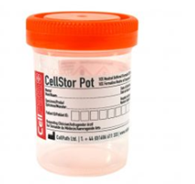
60ml Neutral Buffered Formalin (Supplied filled)

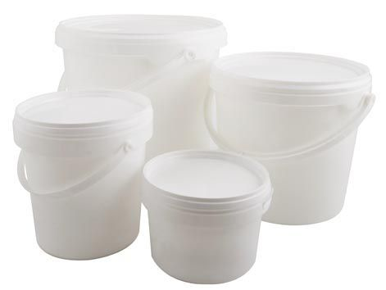
Histology specimen buckets (supplied empty) from 500ml – 25litre

Samples for routine histology should be placed into neutral buffered formalin fixative, in a container that provides sufficient volume to allow the sample to move freely suspended within the formaldehyde solution. There should be an appropriate amount of formalin according to the size of the sample (for optimal rapid fixation it is recommended that the formalin volume should be at least 10X the volume of tissue - formalin should cover the sample entirely whilst allowing for some empty space at the top of the container to avoid spillage upon opening in the laboratory
All theatre and clinic routine histology samples should reach the laboratory within a few hours of collection.
Samples from outside the hospital that cannot be delivered on the same day should be stored overnight and delivered the next morning.
Histology samples do not require refrigeration.
Delayed delivery histology samples may result in over fixation, which can result in reduced sensitivity for a proportion of the diagnostic histopathology tests.
ENDOSCOPIC BIOPSIES
These specimens should be placed onto small pieces of filter paper (obtained from the Histopathology Department) before being gently immersed in formalin. The Muscle Layer of the sample should be placed flat against the paper if possible to allow correct orientation and fixation of the specimen.
NEEDLE BIOPSIES
Place the specimen on filter paper before fixing.
CONE BIOPSIES OF THE CERVIX
Place the specimen in formalin intact.
BONE MARROW TREPHINE AND LYMPH NODE BIOPSIES FOR LYMPHOMA DIAGNOSIS
Follow instructions for routine histology samples. DO NOT complete a local histology request card or send to Histopathology. Specimens should immediately be sent to Blood Sciences with a completed Barts request form for onward referral to Barts. Returned reports are entered by Histopathology.

GOUT CRYSTAL HISTOLOGY INVESTIGATIONS
Histology samples requiring gout crystal investigations must be sent in 70% alcohol – please call laboratory before sending.

IMMUNOFLUORESCENCE INVESTIGATION ON SKIN
Skin samples for immunofluorescence should be collected into specialised transport media which is supplied from the Histopathology laboratory – please call laboratory before sending.

FROZEN SECTION INVESTIGATION
Histology samples requiring frozen sections (pre-booked only see section 6.1 above) should be delivered to the department fresh and as quickly as possible. They should be placed into a suitable sized container – samples should not be forced into or squashed in containers. Containers are available of varying sizes, (50ml to 25litre).
DO NOT add fixative or saline as a frozen section cannot be performed if this occurs.
Frozen section samples must be delivered to the laboratory IMMEDIATELY.

DIAGNOSTIC CYTOLOGY SAMPLE HANDLING & STORAGE
Diagnostic cytology (non-gynae) samples are unfixed and will start to deteriorate immediately after collection. For this reason prompt transportation to the laboratory will optimise sample quality for cytological assessment.
If the result is CLINCIALLY URGENT contact the laboratory to warn of the sample being sent, write URGENT on the request card, stating the reason for urgency, contact details or the date by which the report is needed.
Diagnostic cytology samples should be collected as follows:
SAMPLES OF FLUID FROM BODY CAVITIES, CYSTS, AND JOINT FLUIDS
Collect into clean plain universal containers
Do not use containers with preservative.
Where there is more than one universal container of fluid the laboratory recommends a representative sample is taken from the fluid, and collected into one universal container.
Approximately 20ml of fluid is required.
ENDO BRONCHIAL ULTRASOUND (EBUS) SAMPLES
Collect into formalin pots
URINE CYTOLOGY SAMPLES
Collect into plain universal containers.
Freely voided, catheter, ileal conduit specimens or bladder/ureteric washings may be collected.
The method of collection should be noted on the request form.
Mid-morning specimens are normally required.
For voided urine, an aliquot of the whole voided sample (approx. 20ml) should be submitted (NOT mid-stream samples).
DO NOT use centrifuge tubes as containers for cytology samples.
Give relevant information regarding previous cystoscopic findings and clinical history.
Details of present treatment, particularly radiotherapy or cystoscopy, are most important as these procedures can affect the microscopic appearance of the sample.
FINE NEEDLE ASPIRATES
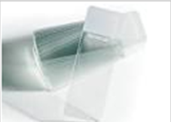
Smears prepared from material aspirated by this technique should be submitted on clean frosted end glass slides.
Clearly label in PENCIL with the patient's name, date of birth and unique number
Clearly label in PENCIL whether air dried or fixed (i.e. A.D. or F).
A flat and even preparation is required and, if necessary, the tip of the needle may be used to tease out any thick parts of the sample.
After spreading gently the slides should be either rapidly dried by waving in the air, or fixed immediately by spraying the cell spread with spray cytological fixative, before placing in the slide transport container.
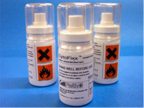
50ml Spray fixative for cytology

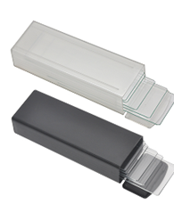
Plastic slide mailer/transporter

If a large volume is collected, then the excess material can be expelled into a container and sent to the laboratory along with at least two prepared slides.
Spray fixative can be obtained from the laboratory.
The laboratory recommends that both spray fixed and air dried slides are prepared for each sample
For samples where there is a large volume, the sample can be placed into a clean universal container and delivered to the laboratory.
BRONCHIAL WASHINGS
Suspend in saline in a plain universal container.
BRONCHIAL BRUSHINGS
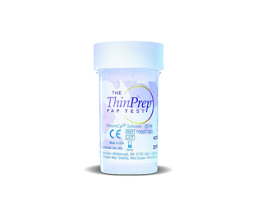
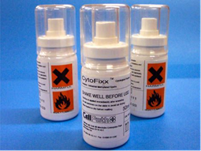
Collected in a Hologic ThinPrep ® LBC sample vial or spray fixed on a glass slide.

SPUTUM SAMPLES
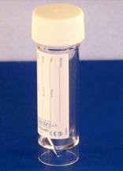
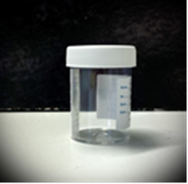
Collect into a sterile universal container or sputum pot.
Sputum cytology has limited clinical value, usually reserved for patients unable to undergo bronchoscopy.
Up to three separate samples, collected on different days may be submitted.
Ideally, after chest physiotherapy, patients should be encouraged to produce a deep cough sample, as saliva and nasopharyngeal material alone are useless for diagnosis. The specimen should be produced before any food or drink is taken.
Please supply sufficient clinical information to indicate the reason for requesting cytological examination of sputum.
Diagnostic cytology (non-gynae) samples should be delivered to the laboratory the same day.
All theatre and clinic samples should reach the laboratory within a few hours of collection.
Diagnostic cytology samples can be stored in a refrigerator overnight with the exception of joint fluids which should never be refrigerated or the result could be compromised.
It is recommended that service users do not store or refrigerate diagnostic cytology samples overnight at Colchester Hospital because these samples are currently transported to the Ipswich laboratory for processing therefore it is preferable that they are delivered to the Colchester laboratory without delay.

MUSCLE BIOPSY SAMPLE HANDLING & STORAGE
Although many of the morphological changes in skeletal muscle can be seen with a routine histology stain, enzyme histochemical methods are necessary to evaluate the presence of different fibre types. Enzymes are labile, requiring that enzyme histochemistry needs to be carried out on frozen sections of unfixed tissue. For these reasons both a fresh and a formalin-fixed specimen are required.
Muscle biopsy samples for enzyme histochemical investigations are carried out on frozen sections of unfixed tissue so MUST be handled in a specific way.
Skeletal muscle must be sent directly to the Histopathology laboratory as follows:
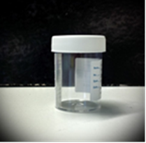
Fresh tissue in a in a sterile specimen pot (sputum pot) – for enzyme investigation. These requirements have changed – DO NOT send specimens in saline or wrapped in gauze.
Sterile Sputum pot for fresh tissue

Fixed tissue in a formalin filled pot – for routine investigation

Formalin filled pot for fixed tissue

Follow the Muscle Biopsy Theatre Procedure – (CELL-COL-INFO-37 – available from the laboratory upon request)
- Place the muscle biopsy in a clean sterile specimen pot.
- Send the specimen directly to Histopathology by urgent porter, in a red urgent specimen bag with the completed Histopathology request card and the completed Addenbrooke’s muscle biopsy request form.
- Phone the Histopathology department (extension 8341) immediately after the specimen has been picked up by the porter.

Documents Required for Muscle Biopsies
- Completed Addenbrooke’s Muscle Biopsy Request Form (CELL-COL-EXT-103)
- Completed Histopathology Request Card

It is recommended that service users telephone the laboratory before sending a muscle biopsy to ensure all procedures are briefed and followed accurately. Fresh samples are transported to the Addenbrooke’s laboratory for enzyme investigation. For this reason it is important that this is co-ordinated in liaison with the laboratory in order that suitable transport can be arranged.

PRODUCTS OF CONCEPTION SAMPLE HANDLING & STORAGE
Products of conception samples histological processing should be placed into a suitable sized container – samples should not be forced into or squashed into containers. Containers are available of varying sizes, (20ml to 25litre) – see routine histology above.
Products of conception, or ectopic pregnancies also require a fully completed patient consent form (FRC1 form available on the intranet as an appendix to the Sensitive Disposal of Foetal Material, Limbs, Tissue & Organs Policy & Procedure PP094) must be sent in addition to the Histopathology request card. Please contact the mortuary directly on 01206 742302 (internal extension 2302) if specimens are for disposal only.
DO NOT send umbilical cord snip specimens for cytogenetic testing to Histopathology, these should be sent to the Blood Sciences lab for onward referral.
Placenta and umbilical cord specimens do not require an FRC1 form.

Time limits for requesting additional examinations/tests
Histopathology specimens are routinely kept for four weeks after reporting before disposal.
Tissue blocks and slides are routinely kept for 30 years before disposal.

Transport of Histopathology Samples
All samples, unless stated, must be sent to the laboratory as soon as possible either in person or via a porter or transport system. The vacuum POD/shoot system MUST NOT be used for Histopathology samples.
All samples are to be kept at ambient temperature unless stated otherwise above.

TRANSPORT OF SAMPLES FROM GP SURGERIES
The Pathology service provides a daily collection service from all GP surgeries, via contracted ERS courier transport. Samples for collection should be individually bagged then placed in a large sealed plastic bag with sufficient wadding to absorb spills.

TRANSPORT OF SAMPLES TO OFFSITE REFERRAL LOCATIONS
The Pathology service uses the ERS courier service to transport samples where possible to offsite locations in the local geographical area (e.g. London Hospitals). Where locations are not served by ERS, Royal Mail, or an alternative courier may be used as an alternative (depending on clinical urgency, specimen type and status), however ERS couriers are preferentially used where possible.

TRANSPORT OF SAMPLES FROM HOSPITAL WARDS, THEATRES AND CLINICS
Histopathology samples are in the main not repeatable tests, to safeguard these precious samples they should be transported by porters using the tele tracking system available on Trust PC desktops or via the intranet.
Histopathology samples must not be left at the Blood science or Microbiology departments, as this breaks the chain of custody and risks delays / sample loss.
Once a TeleTracking job is booked the Portering service will collect the samples and deliver directly to the Histopathology service during the hours of 06:00 and 22:00. Any samples booked for portering outside of these hours will be collected the following morning at 07:30. Upon arrival in the Histopathology Department a member of the Histopathology team will take receipt of samples.
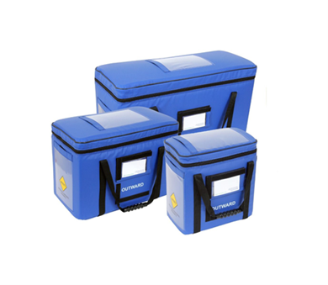
Histopathology samples are transported by porters in specifically designed bags.
You MUST ensure all sample lids are screwed tight or snap shut before placing into the larger transport bags. This is to prevent the leakage of formalin which is classified as a class 1B carcinogen and should be handled within a controlled environment with minimum exposure. Any spillages during transport to the laboratory are a risk to the public, portering staff and the receiving laboratory. Spillages should be absorbed using Formaspill® granules to neutralise the formalin, prior to scooping and disposal into clinical waste.
Incorrectly packaged Histopathology samples that release biological or chemical hazards into the environment will be recorded on Datix as a Health and Safety incident.

CHAIN OF CUSTODY AND SAMPLE TRANSPORT RECORDS
Users of our service should operate a sample transport log with details of samples, sent time, tag number & time of collection of by portering staff. This ensures the chain of custody is recorded.
The Histopathology Department records the sample receipt time within the department to ensure a full chain of custody.
Samples requiring frozen section must be transported immediately to the department – following instruction above
Radioactive samples should be retained at source until deemed safe to send.

Factors affecting laboratory tests

HISTOPATHOLOGY
- Multiple specimen pots must be easily distinguishable from each other and must be numbered / lettered in the same order as they appear on the request card. Failure to do so will result in the specimen being rejected and returned to the sender.
- All specimens must be sent in formalin fixative unless prior arrangements have been made with the Laboratory or require a frozen section and has been pre-booked. Fresh specimens received without prior arrangements will be challenged.
- Specimens from known TB patients must always be sent in formalin fixative unless prior arrangements and notification are made with the laboratory
- The quality of the results obtained is affected by the quality of the sample received.
- Histopathology samples must be transferred promptly to the formalin fixative solution. Delays in fixation can affect the morphology of the tissue sample and also impact on the quality of some diagnostic tests. This can have a negative impact on the quality of the diagnostic result.
- Histology samples should be transferred to the histopathology service as soon as is possible, ideally on the same day. Delays in transfer result in prolonged fixation which can be detrimental to the quality of some diagnostic tests.
- Unlabelled / incompletely labelled histology specimens will be returned with the request form to the clinician requesting the test, or the clinician will be given the opportunity to visit the laboratory and identify the specimen him/ herself.
- Laboratory staff will not intervene in the labelling and identification process.

DIAGNOSTIC CYTOLOGY
- Delays in transportation of cytology samples to the laboratory must be avoided.
- Unlabelled / incompletely labelled cytology samples will be returned with the request form to the clinician requesting the test, or the clinician will be given the opportunity to visit the laboratory and identify the specimen him/ herself.
- Laboratory staff will not intervene in the labelling and identification process.

Turnaround Times
The Histopathology department aims to meet the below turnaround times for specimens received:
Cancer Biopsies: 90% of samples on a cancer pathway processed in 3 days
90% of samples on a cancer pathway reported within 7 days of receipt
Cancer Resection: 90% of resections for patients on a cancer pathway to be reported within 14 days of receipt.
Routine Samples: 90% of samples for patients on a routine pathway and reported internally to be reported within 28 days of receipt
Outsourced Samples: 90% of outsourced samples to be reported within 42 days of receipt.

Summary of Tests Referred to Other Laboratories
Tests not available at Colchester are referred to other laboratories which have their accreditation to UKAS reviewed by the Colchester Laboratory. This is not an exhaustive list of tests; some complex cases may be sent at the pathologist’s discretion to a nationally recognised expert in the area of interest.
Test | Referral Centre
Breast Her2 | Ipswich Histopathology
Breast FISH | Source Bioscience
Breast PDL1 | Health Service Laboratories (HSL)
Breast BRCA and HRD | Northwest Genomics Hub, Manchester
Breast Oncotype DX | Genomic Health
Skin BRAF | East Genomics Hub, Cambridge
MMR | Health Service Laboratories (HSL)
BRAF and MLH1 hypermethylation | East Genomics Hub, Cambridge
KRAS/NRAS/BRAF | East Genomics Hub, Cambridge
Gastric Her2 | Source Bioscience
Gastric PDL1 | Health Service Laboratories (HSL)
Colonic PDL1/Her2/MMR | Health Service Laboratories (HSL)
Colonic BRAF | East Genomics Hub, Cambridge
Lung EGFR/ALK/PDL1/ROS/RET/MET/KRAS | Birmingham, Queen Elizabeth Hospital
Lung PDL1 | Birmingham, Queen Elizabeth Hospital
Urothelial PDL1 | Birmingham, Queen Elizabeth Hospital
Urothelial BRCA1 and 2 | Birmingham, Queen Elizabeth Hospital
Head and Neck PDL1 | Birmingham, Queen Elizabeth Hospital
NSG sequencing and TSO500 | East Genomics Hub, Cambridge
Medical Renal Biopsies | Addenbrooke’s
Muscle Biopsies | Addenbrooke’s
Non Gynae Cytology (except synovial fluids) | Ipswich Histopathology
Additional stains not carried out in-house | Ipswich Histopathology
Additional stains not carried out in-house or Ipswich | Health Service Laboratories (HSL)
Skin IMF | St. Johns Institute of Dermatology, London
Bacterial PCR (TB) | Leeds Teaching Hospital

Data protection and patient confidentiality
The Data Protection Act 2018 is the UK’s implementation of the General Data Protection Regulation (GDPR).It is closely linked to the Freedom of Information and Human Rights Acts. Its focus is on promoting the rights of individuals in respect of their privacy and the right to confidentiality of their data.

It is the policy of East Suffolk & North Essex Foundation Trust (ESNEFT) that the eight principles underpinning the DPA are fulfilled. The eight Principles are:

1. Personal data shall be processed fairly and lawfully.
2. Personal data shall be obtained for one or more specified and lawful purpose(s) and shall not be further processed in a manner incompatible with that purpose(s).
3. Personal data shall be adequate, relevant and not excessive in relation to those purposes. 4. Personal data shall be accurate and where necessary kept up-to-date.
5. Personal data shall not be kept for longer than is necessary for that purpose.
6. Personal data shall be processed in accordance with the rights of the data subject under the Act.
7. Appropriate technical and organisational measures shall be taken against unauthorised or unlawful processing of personal data and against accidental loss destruction or damage.
8. Personal data shall not be transferred to countries outside the European Economic Area (EEA) without adequate protection.

Escalation in Case of Service Failure
In case of service problems or issues please contact laboratory for advice on the numbers above.
Out of hours please contact the hospital switchboard for access to the emergency contact.

Feedback / Complaints / Incidents
The service works closely with users to ensure the service provided meets the needs of the users. This is achieved through discussions at MDT meetings and user surveys.
User surveys are issued to primary and secondary care, results are reviewed and feedback provided. Where concerns are raised these are considered by the service management and where relevant taken into account to improve the service.
If users would like to feedback comments to the laboratory, please contact the Local Technical Lead for Histopathology or the Specialty Technical Lead for Histopathology.
All complaints should be referred to the ESNEFT complaints team who can be contacted at: pals@esneft.nhs.uk
Incidents relating to this service should be reported on the Datix system available on local PC desktops or on the hospital intranet.
All incidents are fully investigated and recorded on the Datix system.
The ESNEFT Pathology Quality Team in conjunction with the service, monitors all incidents & complaints on a weekly basis and trends on a monthly basis – this information is fed up to board level and used to inform service improvements.

Monitoring Compliance and Effectiveness
This document is subject to periodic review by the Colchester Histopathology department and controlled by quality management software.
The Quality Manager for ESNEFT Histopathology is responsible to ensure this is monitored.

